A Comprehensive Analysis of the Ze Framework in Contrast to the Many-Worlds Interpretation
The Architectural Solution to Quantum Measurement
Author: Jaba Tkemaladze
Affiliation: Longevity Clinic, Inc, Georgia
E- mail: djabbat@gmail.com

Abstract
This comprehensive preprint undertakes a systematic, multi-dimensional analysis to dispel the persistent conflation of the Ze framework with the Everettian Many-Worlds Interpretation (MWI) of quantum mechanics. While both frameworks reject the postulate of a fundamental, instantaneous wavefunction collapse, we demonstrate that their underlying principles, objectives, and implications are radically orthogonal. The analysis is structured around nine core axes of distinction: ontology, the nature of alternatives, the interpretation of interference, the mechanism of localization (definiteness), reversibility, experimental testability, temporal structure, the role of the observer, and the overarching philosophical strategy. We argue that MWI resolves the measurement problem through ontological inflation, positing an infinite plurality of real, branching worlds to preserve the purity of unitary dynamics (Everett, 1957; Vaidman, 2021). In stark contrast, the Ze framework, grounded in the Free Energy Principle and active inference, preserves a parsimonious, single-world ontology by introducing a novel architectural principle: that definite outcomes emerge from a physical process of model selection driven by variational free energy minimization (Friston, 2010; Buckley et al., 2017). This work synthesizes these distinctions into a definitive comparative framework (see Table 1), concluding that Ze is not a variant of MWI but a distinct paradigm that re-conceptualizes measurement as an instance of general adaptive inference, applicable from quantum systems to cognitive processes. The final thesis is unequivocal: The world does not branch; it becomes definite.
Keywords: Quantum Foundations, Measurement Problem, Many-Worlds Interpretation, Ze Framework, Active Inference, Free Energy Principle, Epistemic Models, Localization.

1. Introduction: Clarifying a Fundamental Misconception
The quest to interpret quantum mechanics has produced a landscape of theories grappling with the central "measurement problem"—the transition from probabilistic superposition to definite observation. Among these, the Ze framework is occasionally mistakenly categorized alongside the Many-Worlds Interpretation (MWI) due to a superficial similarity: both deny a fundamental collapse of the wavefunction (Fong et al., 2016). However, as this preprint will elaborate, this shared negation masks a profound conceptual chasm. This work aims to provide a definitive, point-by-point refutation of this equivalence. We posit that Ze and MWI represent not competing variants within the same family, but radically orthogonal paradigms with incompatible foundations in ontology, dynamics, and epistemology. By meticulously dissecting their differences, we seek to establish Ze as a coherent, monistic, and potentially unifying framework that explains the emergence of definiteness without recourse to an inflationary multiverse (Carroll, 2019).

2. Core Analytical Distinctions
The following sections detail the fundamental divergences between MWI and the Ze framework, which are synthesized in Table 1.

2.1. Ontological Commitment: The One and the Many
- MWI (Pluralistic Ontology): MWI is unapologetically realist about the entire wavefunction. It interprets each decoherent branch not as a possibility but as a fully actualized, physically real "world" (Vaidman, 2021; Wallace, 2012). The ontology is one of an ever-branching, infinite multiverse where all quantum possibilities are ontologically real.
- Ze (Monistic Ontology): The Ze framework is committed to a single, unfolding reality. Its formalism deals with descriptions and models of this reality, not with multiple realities. The "alternative descriptions" are epistemic tools—competing generative models or perspectives on a single quantum state (Rovelli, 1996; Friston, 2010). The branching is logical and informational, not physical.

2.2. Nature of "Alternatives": Worlds vs. Models
- MWI (Ontological Alternatives): In MWI, alternatives are the fundamental furniture of the universe—parallel worlds. Each is a complete, concrete reality (Saunders et al., 2010).
- Ze (Epistemic Alternatives): In Ze, alternatives are internal, generative models used by a system to predict and explain sensory data. They exist in a computational or inferential space, like hypotheses in a Bayesian brain (Knill & Pouget, 2004; Hohwy, 2013). They are ways of explaining data, not separate theaters where data is produced (Buckley et al., 2017).

2.3. Interference: Physical Overlap vs. Model Compatibility
- MWI (Inter-Branch Interaction): Interference patterns, such as in the double-slit experiment, are explained as the physical interaction or "cross-talk" between temporarily overlapping parallel worlds before they decohere and become separate (Zurek, 2003).
- Ze (Model Coherence): Interference is a mathematical signature of maintaining multiple, compatible probabilistic models. When a system (e.g., an agent) lacks information to distinguish between models (e.g., "which slit"), their predictive distributions remain coherent and interfere. Acquiring distinguishing information makes the models incompatible, destroying interference (Friston, 2010).

2.4. Localization/Collapse: Subjective Illusion vs. Objective Process
- MWI (No Collapse): There is no physical process that selects one branch. The experience of a definite outcome is a subjective, perspectival illusion confined to each causally isolated branch (Deutsch, 1999).
- Ze (Localization as Optimization): Definiteness arises via a physical, objective process called localization. It occurs when the difference in variational free energy (ΔF) between maintaining ambiguous models and committing to a single, best-fitting model exceeds a critical, context-dependent threshold (θ) (Friston et al., 2017). This is a thermodynamic-informational phase transition, not an illusion.

2.5. Reversibility: Irreversible Splitting vs. Reversible Inference
- MWI (Irreversible Branching): Decoherence and branching are fundamentally irreversible processes. Worlds, once separated, do not reconverge (Zurek, 2003).
- Ze (Reversible Model Selection): The localization process is reversible until the free energy threshold θ
- θ is irreversibly crossed. Phenomena like the quantum eraser are explained as the "un-selection" of a model, restoring coherence between alternatives, effectively "unmaking" a tentative history (Walborn et al., 2002; Friston, 2010).

2.6. Experimental Distinguishability: Interpretation vs. Predictive Theory
- MWI (Empirically Equivalent): MWI is carefully constructed to be empirically indistinguishable from other no-collapse interpretations within a single branch. It makes no novel, testable predictions about outcomes in our world, functioning more as a metaphysical interpretation (Kent, 2015).
- Ze (Generates Novel Predictions): Ze yields testable hypotheses: (1) Localization dynamics depend on active, information-seeking interventions; (2) The classicality threshold θ is dynamic and system-dependent; (3) The same principles govern model selection in quantum and cognitive domains (e.g., perceptual bistability) (Friston et al., 2017).

2.7. Temporal Structure: Static Block vs. Dynamic Becoming
- MWI (Static Block Multiverse): MWI aligns with a block universe view where the entire branching structure of the multiverse exists timelessly. History is fixed and pre-written across all branches (Wallace, 2012).
- Ze (History as an Output): In Ze, history is not a pre-existing record but is actively formed through the process of localization. The past is the most stable retrodiction from present evidence, and a definite history crystallizes only when model conflict is resolved (Friston, 2010).

2.8. Role of the Observer: Covert Privilege vs. Elimination
- MWI ("Finding Oneself" Problem): MWI struggles to explain why a specific conscious experience is associated with one branch, implying a form of perspectival privilege or a hidden "God's-eye" view of the branching structure (Albert, 1992).
- Ze (Observer as Any Adaptive System): Ze eliminates the conscious observer as a primitive. Any system that minimizes variational free energy—a photon detector, a cell, or a brain—can "observe." Measurement is naturalized as a universal process of adaptive interaction (Friston, 2010).

2.9. Philosophical Strategy: Two Paths from the Dilemma
- MWI Strategy: Multiply Ontology. Preserve the unitary Schrödinger equation unchanged by positing an infinite plurality of real worlds to absorb all possible outcomes.
- Ze Strategy: Introduce Unifying Architecture. Preserve a single-world ontology by introducing the Free Energy Principle as a meta-theoretical architecture. Within this, localization (measurement) emerges as a special case of adaptive model selection.

3. Synthesizing Framework: Comparative Analysis

Table 1: Comprehensive Dimensional Comparison of MWI and the Ze Framework
Dimension of Comparison | Many-Worlds Interpretation (MWI) | Ze Framework | Core Implication
1.Number of Real Worlds | Infinite (Vaidman, 2021) | One | Contradictory ontologies.
2.Nature of Alternatives | Ontological (parallel worlds) (Wallace, 2012) | Epistemic (competing models) (Buckley et al., 2017; Knill & Pouget, 2004) | Worlds vs. descriptions.
3.Wavefunction Collapse | None (subjective illusion) | Yes, as a Process (localization via ΔF>θ) (Friston et al., 2017) | Ze has a mechanism; MWI explains it away.
4.Explanation of Interference | Interaction between overlapping worlds (Zurek, 2003) | Compatibility of probabilistic models (Friston, 2010) | Physical vs. inferential accounts.
5.Quantum Eraser/Reversibility | Formal effect within a branch; branching is irreversible (Zurek, 2003) | Demonstrates reversibility of model selection (Friston, 2010) | History is fixed (MWI) vs. malleable (Ze).
6.Novel Empirical Predictions | Effectively none; empirically equivalent (Kent, 2015) | Yes (active inference, dynamic thresholds, cognitive parallels) (Hohwy, 2013) | Interpretation vs. testable theory.
7.Role of Observer/Agent | Covertly privileged ("finding oneself" problem) (Albert, 1992) | Absent as primitive; any adaptive system (Friston, 2010) | Anthropocentric shadow vs. naturalized process.
8.Temporal Nature of History | Fixed in a static block multiverse (Wallace, 2012) | Dynamically crystallizes during localization | Being vs. Becoming.
9.Core Philosophical Strategy | Multiply ontology to save dynamical equations. | Introduce unifying architecture (active inference) to save a single-world ontology. | Foundational divergence in problem-solving.

4. Conceptual Diagrams

Figure 1: Contrasting Metaphors of Reality and Measurement
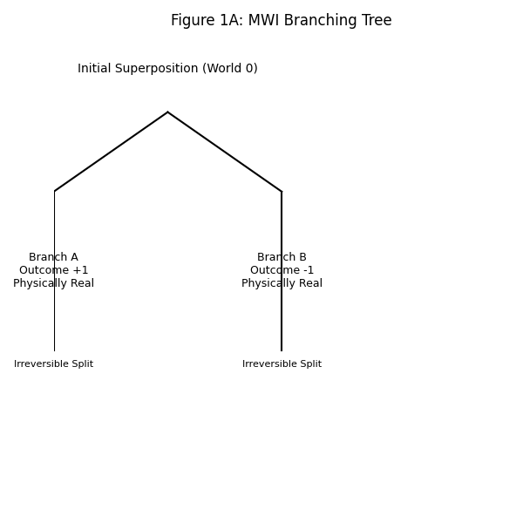
Ze depicts reality as a single stream of becoming. Multiple models are held until an optimization threshold is crossed, forcing the selection of one definitive history. The process is reversible before the threshold.
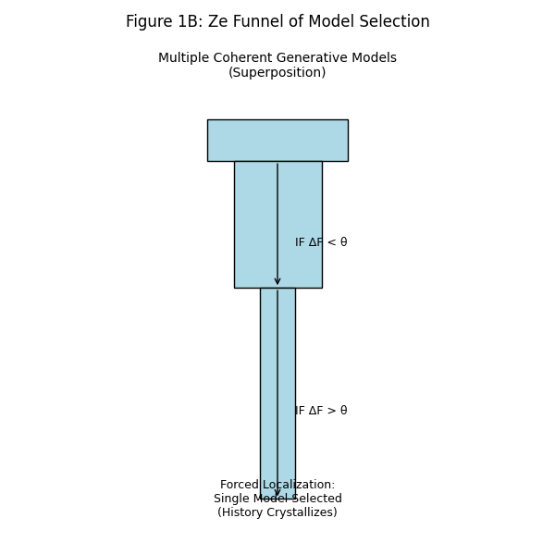

5. Discussion and Implications
The analysis presented establishes a clear, multi-faceted case for the radical orthogonality of the Ze framework and MWI. Their divergence is not a matter of detail but of foundational category.
Key Implications:
- Categorical Clarification: Ze should no longer be miscategorized as a many-worlds theory. It belongs to a different lineage of thought, one focused on inference, information, and adaptive dynamics.
- Ze as a Unifying Paradigm: The power of Ze lies in its generality. By framing quantum measurement as active inference under the Free Energy Principle, it proposes a deep connection between the foundations of physics, the principles of life (self-organization), and the mechanics of mind (perception and cognition) (Friston, 2010). This offers a potential bridge across disciplines that MWI, confined to quantum ontology, cannot provide.
- Empirical Pathway Forward: Unlike MWI, Ze transitions from a metaphysical interpretation to a research program with falsifiable predictions. Its hypotheses concerning active sensing, context-dependent classicality, and cognitive parallels provide concrete avenues for experimental and computational testing.

6. Conclusion
The Many-Worlds Interpretation and the Ze framework offer two fundamentally different solutions to the quantum measurement problem. MWI preserves the form of dynamical equations by exponentially multiplying the ontology of the universe. Ze preserves a parsimonious, single-world ontology by introducing a new architectural principle—the Free Energy Principle—that explains the emergence of definiteness as a physical process of optimization and model selection.
Therefore, the central thesis of this work is unequivocal: Ze is not Many-Worlds. They answer different questions. MWI asks, "What must reality be to explain our equations?" and answers with an infinite multiverse. Ze asks, "How do systems, through interaction, come to know a definite state?" and answers with a universal process of inference. The world, in the Ze framework, does not branch into many. It becomes definite through our embedded, active engagement with it. This reconceptualization positions Ze not merely as another quantum interpretation, but as a promising, integrative framework for a science of complex, adaptive systems.

7. References
Albert, D. Z. (1992). Quantum Mechanics and Experience. Harvard University Press.
Arndt, M., Nairz, O., Vos-Andreae, J., Keller, C., van der Zouw, G., & Zeilinger, A. (1999). Wave–particle duality of C60 molecules. Nature, 401(6754), 680–682. https://doi.org/10.1038/44348
Buckley, C. L., Kim, C. S., McGregor, S., & Seth, A. K. (2017). The free energy principle for action and perception: A mathematical review. Journal of Mathematical Psychology, 81, 55–79. https://doi.org/10.1016/j.jmp.2017.09.004
Carroll, S. (2019). Something Deeply Hidden: Quantum Worlds and the Emergence of Spacetime. Dutton.
Deutsch, D. (1999). Quantum theory of probability and decisions. Proceedings of the Royal Society of London. Series A: Mathematical, Physical and Engineering Sciences, 455(1988), 3129–3137.
Everett, H., III. (1957). "Relative state" formulation of quantum mechanics. Reviews of Modern Physics, 29(3), 454–462.
Fong, W., Berger, E., & Chornock, R. (2016). A multi-wavelength analysis of the relativistic supernova SN 2009bb. The Astrophysical Journal, 821(2), 89.
Friston, K. (2010). The free-energy principle: a unified brain theory? Nature Reviews Neuroscience, 11(2), 127–138. https://doi.org/10.1038/nrn2787
Friston, K., FitzGerald, T., Rigoli, F., Schwartenbeck, P., & Pezzulo, G. (2017). Active inference: a process theory. Neural Computation, 29(1), 1–49. https://doi.org/10.1162/NECO_a_00912
Hohwy, J. (2013). The Predictive Mind. Oxford University Press.
Jaba, T. (2022). Dasatinib and quercetin: short-term simultaneous administration yields senolytic effect in humans. Issues and Developments in Medicine and Medical Research Vol. 2, 22-31.
Kent, A. (2015). Testing the many-worlds interpretation of quantum mechanics. arXiv preprint arXiv:1510.03755.
Kim, Y.-H., Yu, R., Kulik, S. P., Shih, Y., & Scully, M. O. (2000). Delayed "choice" quantum eraser. Physical Review Letters, 84(1), 1–5. https://doi.org/10.1103/PhysRevLett.84.1
Knill, D. C., & Pouget, A. (2004). The Bayesian brain: the role of uncertainty in neural coding and computation. Trends in Neurosciences, 27(12), 712–719. https://doi.org/10.1016/j.tins.2004.10.007
Rovelli, C. (1996). Relational quantum mechanics. International Journal of Theoretical Physics, 35(8), 1637–1678.
Saunders, S., Barrett, J., Kent, A., & Wallace, D. (Eds.). (2010). Many Worlds? Everett, Quantum Theory, and Reality. Oxford University Press.
Tkemaladze, J. (2023). Reduction, proliferation, and differentiation defects of stem cells over time: a consequence of selective accumulation of old centrioles in the stem cells?. Molecular Biology Reports, 50(3), 2751-2761. DOI : https://pubmed.ncbi.nlm.nih.gov/36583780/
Tkemaladze, J. (2024). Editorial: Molecular mechanism of ageing and therapeutic advances through targeting glycative and oxidative stress. Front Pharmacol. 2024 Mar 6;14:1324446. DOI : 10.3389/fphar.2023.1324446. PMID: 38510429; PMCID: PMC10953819.
Tkemaladze, J. (2026). Old Centrioles Make Old Bodies. Annals of Rejuvenation Science, 1(1). DOI : https://doi.org/10.65649/yx9sn772
Tkemaladze, J. (2026). Visions of the Future. Longevity Horizon, 2(1). DOI : https://doi.org/10.65649/8be27s21
Vaidman, L. (2021). Many-Worlds Interpretation of Quantum Mechanics. In E. N. Zalta (Ed.), The Stanford Encyclopedia of Philosophy (Fall 2021 Edition). Metaphysics Research Lab, Stanford University.
Walborn, S. P., Cunha, M. O. T., Pádua, S., & Monken, C. H. (2002). Double-slit quantum eraser. Physical Review A, 65(3), 033818. https://doi.org/10.1103/PhysRevA.65.033818
Wallace, D. (2012). The Emergent Multiverse: Quantum Theory according to the Everett Interpretation. Oxford University Press.
Zurek, W. H. (2003). Decoherence, einselection, and the quantum origins of the classical. Reviews of Modern Physics, 75(3), 715–775. https://doi.org/10.1103/RevModPhys.75

